Rotary Club of Kathmandu Mid-Town
Breakfast Chatter




4 November 2011 The Weekly Bulletin of Rotary Club of Kathmandu Mid-Town Bc-11.4/011-12

District: 3292 Web: www.rotarymidtown.org.np Club Id : 26776

NOVEMBER IS THE ROTARY FOUNDATION MONTH
The Rotary Foundation of Rotary International was established in 1917 as an endowment fund. It was named The Rotary Foundation by the 1928 convention. In 1931, it was organized as a trust, and in 1983, it was established as a not-for-profit corporation under the laws of the State of Illinois, USA. The Rotary Foundation is operated exclusively for charitable and educational purposes by the Trustees of The Rotary Foundation in accordance with the Foundation’s articles of incorporation and bylaws.

Friday, 21 October:
Rtn Kul C Gautam, in-house speaker, provided de-briefings of his presentation in Rotary Conference for Development and Cooperation held in Colombo, SriLanka, on 4-5 September 2011. Four Rotarians from Nepal including Kul attended the conference. He suggests that participation in such international conference should be well planned so that Rotary Nepal could benefit better and we could present our case favourably.
He called on Rotarians in the region to explore possibility of initiating and supporting programs for development of sports, music and art to give greater importance to these important human values and qualities to raise our younger generation as multi-talented individuals, capable of exercising leadership role in all walks of life in our countries and communities, and in the world.
By appealing to our sense of neighbourly and human solidarity, by mobilizing the thousands of Rotary clubs, and millions of community leaders in our region, and reaching deep within ourselves to promote such human values, we Rotarians can make a profound contribution for regional cooperation and development in South Asia, as it has never happened before.
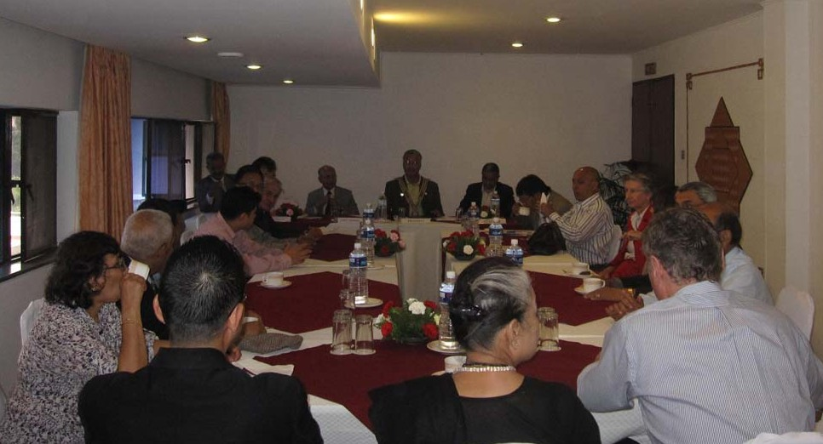
Rtn Kul addressing the Club meeting.

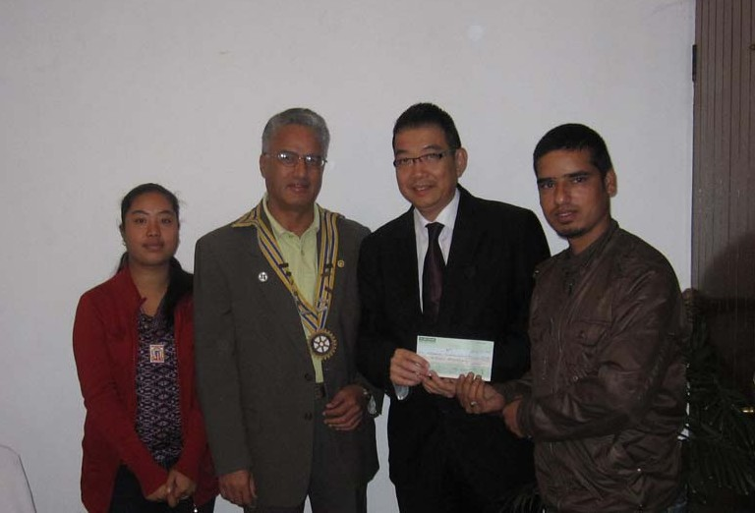
Thai Ambassador Maris and Club President Som handover a cheque of Rs 25,000 to Rotaract President Samir during Club meeting. It was our club's partial contribution to rotaracts/ Interacts to run activities in the first half of RY 2011-12. Ambassador Maris was guest visitor to the Club meeting on 21 Oct

Weekly Meetings and Programs :
Date | Program/Speaker | Program/Topics of Presentation
4 November 2011 | Rotarians from RC of Landshuit
11 November 2011 | CEO of NCell
18 November 2011 | Charter Nite | Charter Nite
25 November 2011 | 2nd Club Assembly | 2nd Club Assembly
2 December 2011 | Dr Donald Sammut | Plastic/ Hand Surgery Experiences

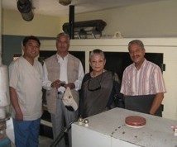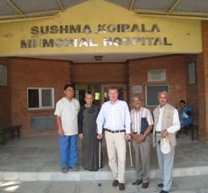

Solar Panels & the 85 kva generator, for which funding has been obtained to provide emergency power supply, compressor & a solar heater module for heating & hot water production for Plastic Reconstruction surgery at the Sushma Koirala Memorial Hospital for the amount US $ 8, 500, provided through MG 74759 by our counterpart Rotary Club of Monchengladbach in Germany. Photos taken during site visit by RC Kathamndu Mid-Town Rtns
President Som, PP Ambica, and IPP Pratap and Rtn Remy from RC Borken, Germany on 20 Oct 2011.

4 November, Friday:
Rotarians from RC of Landshuit, Germany will be talking and providing their presentations.

Membership Satisfaction Questionnaire:
Please remember that the deadline for sending your Feedback on Club performance is
15 Nov 2011
Check your email box, get the Membership Satisfaction Questionnaire sent by Rtn Lisa, Chair of Membership Committee, and return it, duly completed, to lisa@mos.com.np within the deadline.

Rotary-UN Day:
The annual Rotary-UN Day will be held on Saturday, 5 November, at United Nations headquarters in New York City.
Organized by the RI representatives to the UN, this year’s event will feature presentations from senior UN staff and Rotary leaders as well as panel discussions on health, water, literacy, and youth.
Speakers include the Honorable Timothy E. Wirth, president of the United Nations Foundation and Better World Fund; Jacob Kumaresan, executive director of WHO; and Paul Edwards, chief water, sanitation, and hygiene at UNICEF.

RI Convention 2012, Bangkok:
Register now for the 2012 RI Convention in Bangkok, Thailand, 6-9 May, and enjoy an unforgettable experience in the Land of a Thousand Smiles!
Enjoy Thai hospitality. Make friends with fellow Rotarians from around the world. Take in spectacular sights. Taste delicious Thai cuisine. Experience a vibrant culture. Renew your commitment to Service Above Self. And have fun in a world class city. .

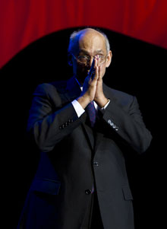
If we want to really achieve the impossible, we have to have not only
persistence, but vision -- we have to be looking past what we are doing now,
at what we can and should be doing in the days and years to come.
RI President Kalyan Banerjee

Life with computers:
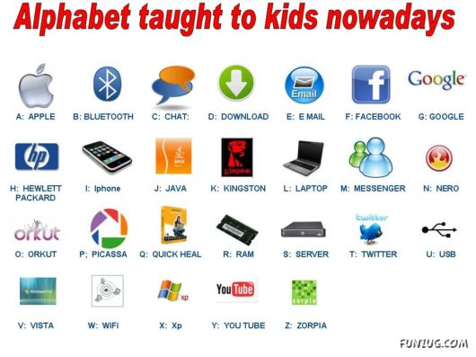

Please send project/activity information, suggestions and photos etc to :
BC Editor: RR Shrestha email: rryes@wlink.com.np

4 November 2011 The Weekly Bulletin of Rotary Club of Kathmandu Mid-Town bc-11.4/011-12

